CfP: Western Association of Slavic Studies Annual Conference (San Antonio, TX, 3–6 April 2024)

Held in conjunction with the World Social Science Association (WSSA), 66th Annual Conference
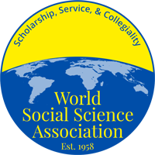
The Call for Papers and registration are now open for the annual conference of the Western Association of Slavic Studies (WASS) to be held from 3-6 April 2024, in San Antonio, TX at the Hyatt Regency.
To submit a proposal for a paper or panel, please register on the World Social Science Association website: https://wssaconference.com/conference-info/2024-conference-overview

We encourage participation of graduate students and advanced undergraduates. The best graduate paper wins a monetary prize and will be eligible for the graduate student paper prize sponsored by ASEEES.

Deadline for submission is 15 January 2024.

Papers from any academic discipline covering the range of Slavic and Eurasian Studies will be accepted.

For more information on the Western Association of Slavic Studies, please see https://www.aseees.org/about/affiliate/regional/western or email robert.niebuhr@asu.edu.

